Lesson 03 – Introduction to Entity Framework Core

**Using Task List**

1. Open **Task List** window from the menu **VIEW**, **Task List**. Use the **Filter** function in the Project heading to display only the Task for current project which is Lesson03.

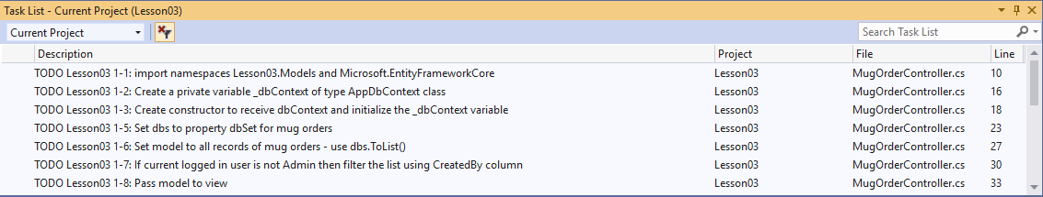

1. **Activity 1:** This activity requires you to setup Entity Framework service, generate entity classes and DbContext class before performing those tasks in the task list
   * + 1. Include the THREE package references (highlighted in yellow) needed to use EF Core with SQL Server in your project by adding the following lines of code in **Lesson03.csproj:**

|  |
| --- |
| <Project Sdk="Microsoft.NET.Sdk.Web">  <PropertyGroup>  <TargetFramework>net5.0</TargetFramework>  </PropertyGroup>  <ItemGroup>  <PackageReference Include="Microsoft.EntityFrameworkCore" Version="5.0.10" />  <PackageReference Include="Microsoft.EntityFrameworkCore.SqlServer" Version="5.0.10" />  <PackageReference Include="Microsoft.EntityFrameworkCore.Design" Version="5.0.10" />  <PackageReference Include="System.Data.SqlClient" Version="4.8.3" />  </ItemGroup>  </Project> |

Press [Ctrl]+[S] to save and check the packages have been downloaded in Solution Explorer.

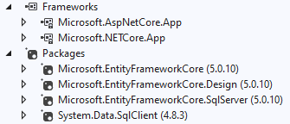

* + - 1. In the Solution Explorer, right-click on **Lesson03** and click Open in Terminal. You should see the **Developer Powershell** window appears in your Visual Studio.

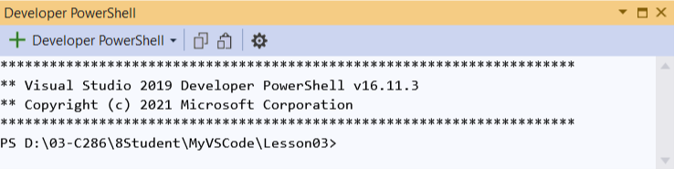

* + - 1. Copy the following one-liner command and paste into the **Developer Powershell** window. To paste is just to right-click within **Developer Powershell**. Press [Enter] to execute the command.

dotnet ef dbcontext scaffold "Data Source=(localdb)\ProjectsV13;Initial Catalog=C286Lesson03;Integrated Security=True" Microsoft.EntityFrameworkCore.SQLServer -o Models -c AppDbContext -f --no-onconfiguring --no-pluralize

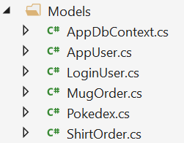

Generated through Entity Framework Scaffold-dbcontext command

* + - 1. Dependency Injection step 1 and 2: Use the slides on Dependency Injection to help you configure EF service in **Startup.cs**. The following yellow markers will tell you where to paste the code. The required code is provided below:

|  |
| --- |
| // Add more Using Statements After Here  using Microsoft.EntityFrameworkCore;  using Lesson03.Models;  // Add Dependency Injection Code After Here  services.AddDbContext<AppDbContext>(  options =>  options.UseSqlServer(Configuration.GetConnectionString("DefaultConnection"))); |

* + - 1. Dependency Injection step 3 to 4: Perform **Tasks 1-1 and 1-3**. Use **C286 L03 Student**, the slides on Dependency Injection, as reference.
      2. Perform **Tasks 1-4 to 1-8** to complete activity 1. **Task 1-4** is in Views/MugOrders/Index.cshtml.
      3. Run the application and click **Cadeau Mug Ordering** link to view the MugOrders/Index action. You should observe that the data is displayed properly.

1. **Activity 2:**
   * + 1. Perform **Tasks 2-1 to 2-8**.
       2. **Task 2-1** is in Views/MugOrder/Create.cshtml.
       3. Run the application and test insert a new mug order to verify the order can be successfully inserted to database.
2. **Activity 3:**
   * + 1. Perform **Tasks 3-1 to 3-2**.
       2. All these tasks are in Views/Sales/Index.html
       3. Run the application and view each step to ensure correct result is obtained.

# Solving the Problem

1. You are suggested to complete the solution in the following order:
   * + 1. Dependency injection – create _dbContext private variable and constructor in ShirtOrderController.
       2. Implement ShirtOrderController/Index action
       3. Implement ShirtOrderController/Create get and post actions
       4. Implement the requirements for Sales Report.

# Testing Your Solution

1. Test Cases:
   * + 1. Add a new shirt order. Verify that the new shirt order is displayed in the index page.

* + - 1. Run Sales Report and review the result.

ss

Provide necessary screenshots here to prove you have successfully tested your web app.

*— End of Worksheet —*